Name:______________________________ Date:________ Hour:_____
B4.2C Describe the structure and function of DNA.

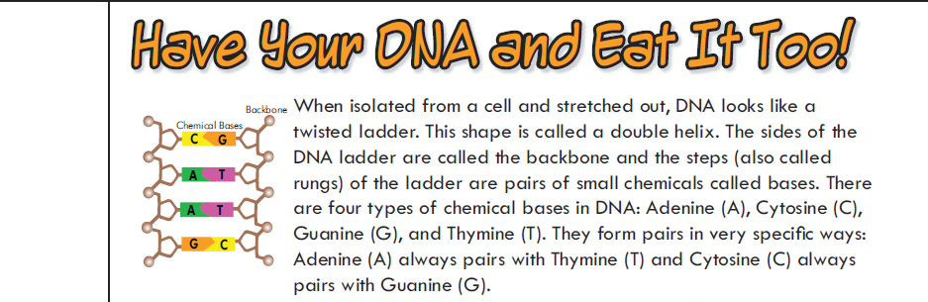
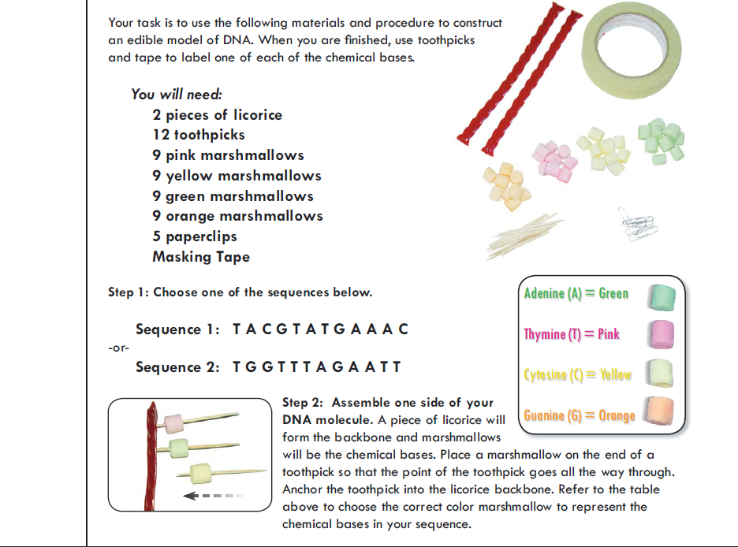

- What is your sequence?

  - _ _ _ _ _ _ _ _ _ _ _ _

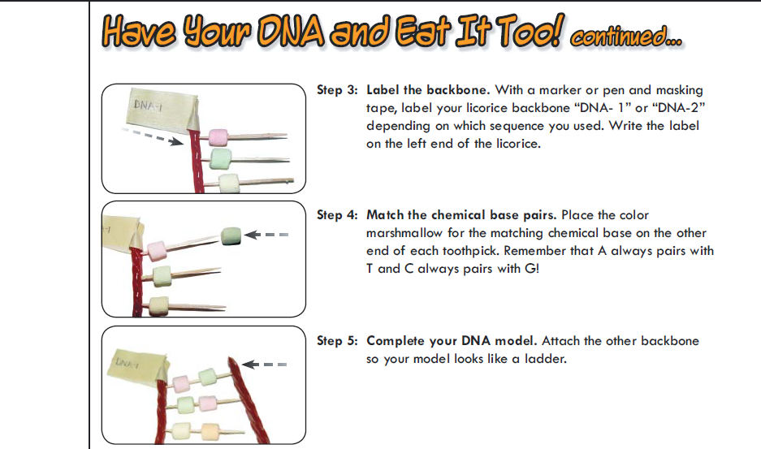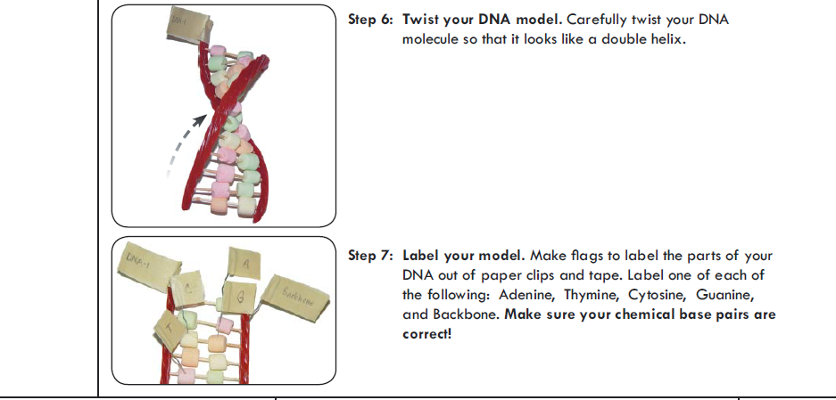

- The arrangement of two bases in the DNA molecule forms a ______________________
- The nitrogenous base A = ______________________________
- The nitrogenous base C = ______________________________
- The nitrogenous base G = ______________________________
- The nitrogenous base T = ______________________________

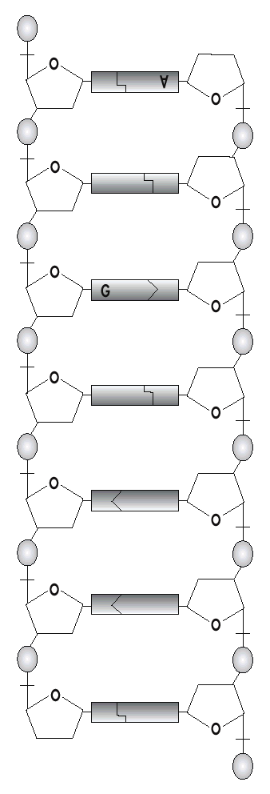
THE DIAGRAM ON THE LEFT represents an untwisted, double-stranded DNA molecule.
- Label each sugar group on the diagram with a letter S.

- Label each phosphate group with a letter P.

- One adenine (A) and one guanine (G) have already been labeled. Label the rest of the nitrogenous bases.

- Circle one nucleotide. What 3 things go together to make one nucleotide?
  - ___________________________________
  - ___________________________________
  - ___________________________________

- The sides of the DNA ladder are made up of alternating
  - ________________________and
  - ________________________ groups.

- The rungs of the DNA ladder are made up of ___________________________

- A is always paired with ________________

- G is always paired with________________

- Paired bases are held together by weak bonds called__________________ bonds.

- When the DNA ladder twists the way it normally does, the shape of the molecule is called a ___________________________

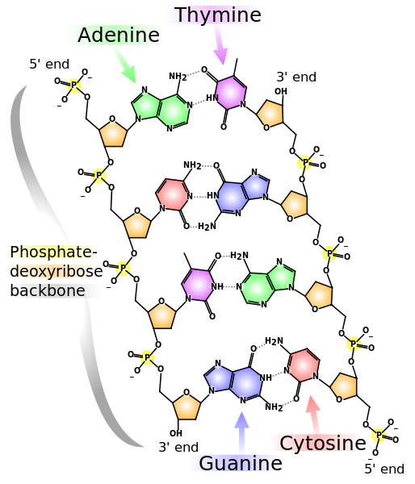
DNA contains inheritable instructions for building and maintaining an organism.

The DNA molecule you have created, can also be drawn like the one on the left.
What are your red licorice strands supposed to be?
____________________ AND
____________________.
What do your marshmallows represent?
____________________
Can you explain these?
DNA structure 
double helix 
base pairing 
STOP. HAVE AN INSTRUCTOR CHECK YOUR KNOWLEDGE OF THE 3 WORDS ABOVE. _______
17. If there are four thymine bases on your model, how many adenine bases will there be? _________
18. If you were to open the entire molecule along the hydrogen bond, what bases would the left side attach to?
And the right side?
19. Would the two new DNA molecules contain the same base nucleotides?

20. Would the two DNA molecules be exact copies of each other? Explain. You may use extra paper.

