Name:______________________________ Date:________ Hour:_____
B5.1A Summarize the major concepts of natural selection (differential survival and reproduction of chance inherited variants, depending on environmental conditions).
B5.1B Describe how natural selection provides a mechanism for evolution.
Written by Dr Paul Willis Edited by Mr. Cistaro
Have you eaten a dinosaur lately? Chances are, unless you're a vegetarian, dinosaurs are part of your regular diet because, if birds evolved from dinosaurs, every time you chow down on a chicken nugget, you're dining on dinosaur. But how do we know birds evolve from dinosaurs? And aren't there some who say that they didn't? It all depends on how you work out relationships.
Working out relationships
Systematics (the science of evolutionary relationships) has undergone a major change over the last couple of decades. It used to be the case that all the features of organisms were important in working out the family tree. But in the mid 1960's the German entomologist Willy Hennig changed all that. Hennig claimed that the only features that carry any useful information about pedigree are the evolutionary novelties shared between organisms.
Suppose we're trying to work out the relationships between a mouse, a lizard and a fish. They've all got backbones so the feature "backbone" is useless; it's a "primitive" character that tells you nothing. But the feature "four legs" is useful because it's an evolutionary novelty shared only between the lizard and the mouse. This implies that the lizard and mouse are more closely related to each other than either is to the fish. Put another way, the lizard and the mouse share a common ancestor that had four legs. The more evolutionary novelties we can find that support a particular relationship, the greater our confidence that the relationship is correct. "Air breathing", "neck" and "amniotic egg" are another three evolutionary novelties that tie the lizard and the mouse together and leave the fish as a more distant relative.
This new approach to systematics is called Cladistics or Phylogenetic Systematics. Cladists identify useful characters then measure their effect on the relationships of the organisms they're studying.
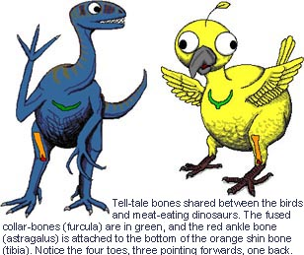
Are Birds Dinosaurs?
The story (almost certainly apocryphal, but they're the best kind) goes something like this: Thomas Huxley (famed as Darwin's Bulldog for his aggressive defense of Natural Selection) was eating quail one evening while ruminating on a paleontological puzzle poised by a strange bone back in the lab. He knew it was the lower leg bone (tibia) of a meat-eating dinosaur but smeared across the bottom of it was an unidentified extra bone. He happened to suck the flesh off the bottom of the quail leg and there, smeared across the bottom of the quail tibia, was the same enigmatic bone. Dealing with a more complete bird leg, Huxley realized that the osseous stranger was the anklebone (astragalus). More importantly, Huxley concluded that the form of the astragalus in both the dinosaur and the bird were so similar that they must be closely related.
Huxley's dino-bird theory fell into disfavor when a new theory postulated that birds evolved from some pre-dinosaurian reptile. In 1916 the Danish medical doctor Gerhard Heilmann published The Origin Of Birds, in which he commented on the many similarities between the skeletons of meat-eating dinosaurs (theropods) and birds. But Heilmann also noted that theropods lacked collarbones (clavicles) which fuse together to become the wishbone (furcula) in birds. Heilmann argued that such a feature could not be lost and then re-evolved at a later date, so theropods couldn't be the ancestors of birds. Thus the theropods were banished from the bird's family tree for the next fifty years.
Then, in the late 1960's, John Ostrom from Yale University noted 22 features in the skeletons of meat-eating dinosaurs that were also found in birds and nowhere else. This reset the thinking on bird ancestry. Subsequent work has found up to 85 characters that tie theropods and birds together. Although some of these characters may be of dubious significance, with so many characteristics shared between theropods and birds, it is a pretty convincing argument in favor of the relationship.
But what of Heilmann's missing collarbones? It turns out that theropods not only had clavicles but that they were fused together into a furcula. Unfortunately for Heilmann, the fossil evidence was somewhat sparse in his day and the few theropod furculae that had been found were misidentified, usually as belly ribs.
Objections to dinobirds
Two vocal opponents of the "Birds Are Dinosaurs" theory are Alan Feduccia, of the University of North Carolina and Larry Martin, from the University of Kansas. They contend that birds evolved from some unknown reptile from a time before the dinosaurs were even a twinkle in a pre-dinosaurian eye. Rather than argue from a cladistic perspective, Feduccia and Martin advance a series of other arguments against the dino-bird hypothesis.
Firstly, Feduccia and Martin claim that flight is most likely to have started from a tree-climbing (arboreal) ancestor but that all the proposed dinosaurian ancestors were ground-dwellers (cursorial). This is the "trees-down" versus the "ground-up" debate and the trees-downers do have a point. There is a variety of modern animals that are gliders, possibly representing a bridge between flying and non-flying animals, and all gliders are arboreal (including frogs, snakes, lizards and a variety of mammals). But the Birds-Are-Dinosaurs crowd argues that an unknown dinosaurian bird-ancestor could have been arboreal or that birds evolved flight from the ground up by chasing and leaping after insects (there are plenty of little theropods thought to have made a living by doing just that).
Most of the arguments raised by Feduccia and Martin against the Birds-Are-Dinosaurs hypothesis are based on differences between birds and dinosaurs. For example, they argue that the theropod ribcage is compressed from side to side while in birds it's compressed more from back to belly. Cladists argue that differences between organisms don't matter; it's the similarities that count. Evolution dictates that organisms will change through time so it's only the features that remain the same that will carry useful information about their origins.

The fossil evidence
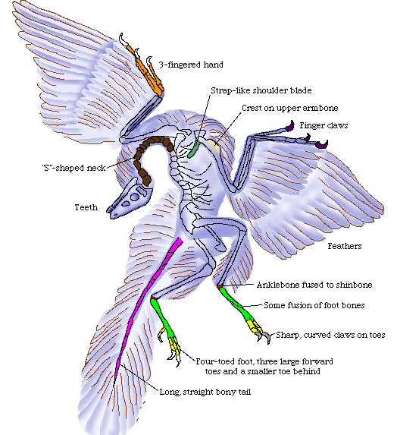
"In the beginning there was Archaeopteryx…" Most combatants in the debate agree that Archaeopteryx is the first bird. Recovered from limestone quarries in southern Germany, Archaeopteryx is a 145 million-year-old, crow-sized skeleton covered in feathers. There is no disputing that Archaeopteryx had feathers, they are clearly preserved along with two of the seven known specimens, and feathers are a distinctly birdie feature. But the skeleton of Archaeopteryx is distinctly non-bird-like with a long bony tail, teeth instead of a beak and claws on the wings. The Birds-Are-Dinosaurs group contends that, if feathers had not been found with Archaeopteryx, it would have been identified as a small dinosaur (in fact the five specimens without feathers had previously been identified as the small dinosaur Compsognathus). The skeleton does have some bird-like features such as a wishbone (furcula) and bird-like feet that suggest to the Birds-Are-Not-Dinosaurs camp that Archaeopteryx is too bird-like to be considered a dinosaur.
The problem now becomes one of linking an ancestor to Archaeopteryx then linking Archaeopteryx to modern birds. This is where things get really interesting because in the last decade several significant dinosaurs with bird-like features and primitive birds with dinosaur-like features have been found around the world.
Bird-like dinosaurs
China has given its name to what may be a feathered dinosaur. Sinosauropteryx comes from rocks thought to be around 130 million years old in northeast China. It's the skeleton of a dinosaur but it's surrounded by a halo of fuzz. No one's quite sure what the fuzz is. It appears to be hair-like structures that could have helped insulate the beast and some authorities think that these are proto-feathers. Whatever the fuzz turns out to be, it's significant that at least one member of the group of dinosaurs thought to be ancestral to the birds was experimenting with a body covering more complicated than bog-standard reptilian scales. Further, the fact that this body covering consists of stiff rods projecting away from the body is at least part of the way to creating a structure something like feathers.
An exceptionally preserved baby theropod happens to also be the only dinosaur ever found in Italy. Details of preservation of Scipionyx include the intestines, liver and chest musculature. And, nestled at the top of the chest is a beautifully preserved furcula. While not the first theropod furcula, it does underline the fact that this bird-bone was close to the heart of meat-eating dinosaurs.
There are other dinosaurs with bird-like features. Unenlagia, from 88 million year old beds of Patagonia folded its arms in the same way that birds do. Oviraptor from Mongolia, once thought to be an egg thief, is now known from several specimens crouching over nests of their own eggs in exactly the same pose as brooding emus. And a reassessment of other theropods reveals such bird-like features as hollow bones and a foot with three functional toes, bird-like features that appeared over 50 million years before the first feeble flying flaps flung Archaeopteryx into the air.
So structurally, the fossils are offering a pretty consistent picture that the Birds-Are-Dinosaurs hypothesis is correct. But there's a hitch. The closest dinosaurian relatives to the birds occur in the fossil record after Archaeopteryx. Unless Velociraptor and kin perfected time travel, there's no way they can be the ancestors of a bird that lived sixty million years earlier. Some recent finds suggest that bird-like dinosaurs did exist earlier than previously thought, but the fossils are scrappy and inconclusive. Given the improbability of fossilization, it's quite possible that pre-Archaeopteryx dino-birds were simply not preserved.
Back to the Chicken Dinner...
In a nutshell, the majority of paleontologists working on the ancestry of birds agree that dinosaurs, particularly small theropods, are the grandparents of present-day parrots, partridges and pigeons. There are some detractors to this emerging orthodoxy but the dino-bird theory is supported by both the most widely used methodology (cladistics) and a rapidly growing collection of primitive birds and advanced meat-eating dinosaurs. A reasonable assessment of the debate would have to conclude that it's all over, including the shouting, in favor of dino-birds.
Perhaps this may cause you to think twice next time you eat chicken. Would you relish your meal quite as much if your humble chicken's relatives (such as Tyrannosaurus) were still around to defend them?
3) (B5.1B)Using the idea that a new species or variety of organism originates [come into existence/being] through the evolutionary process of natural selection, what advantages might feathers confer (give) to those dinosaurs that had them? (You should need extra paper for this.)

