Name:______________________________ Date:________ Hour:_____
B5.1A Summarize the major concepts of natural selection (differential survival and reproduction of chance inherited variants, depending on environmental conditions).
B5.1B Describe how natural selection provides a mechanism for evolution.

BACKGROUND
When Darwin first proposed the idea that all new species descend from a common ancestor, he performed an exhaustive (intense/complete/detailed) amount of research to provide as much evidence as possible. Today, the major pieces of evidence for this theory can be broken down into the fossil record, embryology, comparative anatomy, and molecular biology.

THE FOSSIL RECORD
Below are a series of skulls and front leg fossils of organisms believed to be ancestors of the modern-day horse.

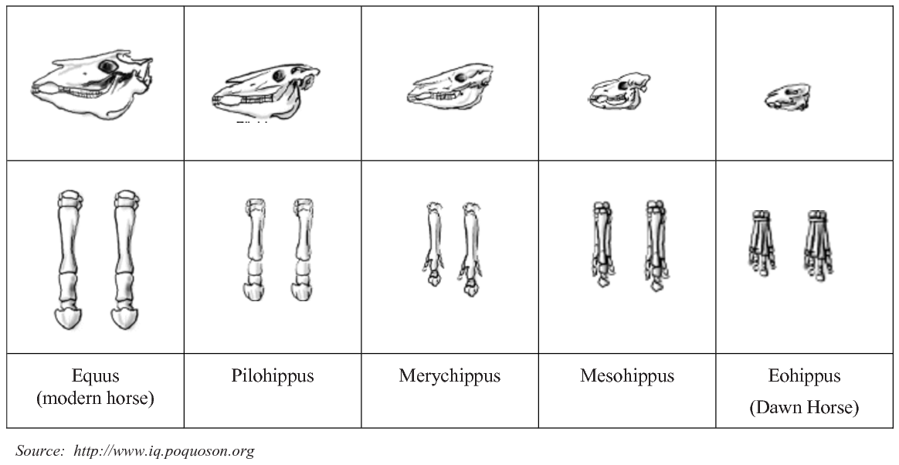

1. Give two (2) similarities between each of the skulls that might lead to the conclusion that these are related species.

2. What is the biggest change in skull anatomy that occurred from the “dawn horse” to the “modern horse?”

3. What is the biggest change in leg anatomy that occurred from the “dawn horse” to the “modern horse?”

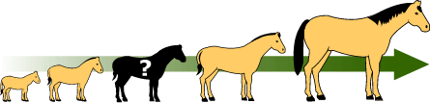
4. You have just looked at some selected fossils from organisms believed to be ancestors to the modern horse. Assume the middle fossil, Merychippus, was missing. Does the fact that some transitional fossils are not preserved disprove evolution? Why or why not?

Instructor Initials_______
EMBRYOLOGY
Below are a series of embryos of different vertebrates at similar stages of development. The earlier the stage, the more similar they are in structure. Notice how each embryo begins with a similar number of gill arches (pouches below the head) and a similar vertebral (backbone) column? In later stages of development, these and other structures are modified into the more familiar forms you may be used to seeing. NOTE: The different groups have been altered to make them the same size for you to compare them.
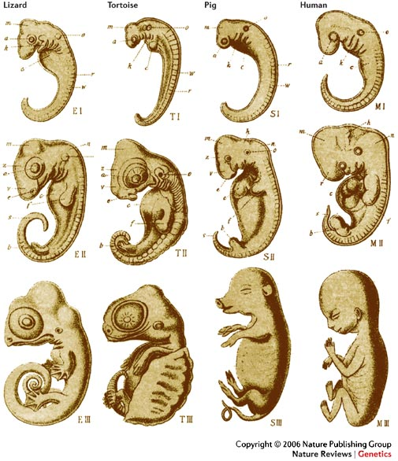
1. Remember the slideshow on homologous vs. analogous? Look carefully at the images. Similarities? List as many as you can find.

COMPARATIVE ANATOMY
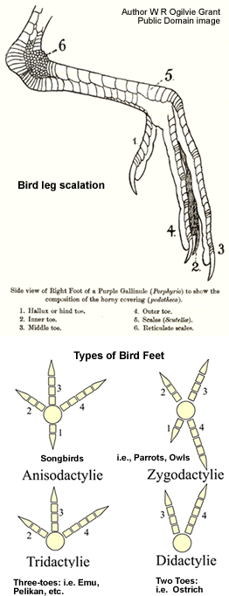
The Cockatoo, is a relatively large white bird found in wooded habitats in Australia and New Guinea.
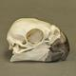 |  | 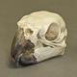 |  | 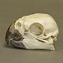

Scientific classification
Domain: Eukaryota
Kingdom: Animalia
Phylum: Chordata
Class: Aves
Order: Psittaciformes
Family: Cacatuidae
Genus: Cacatua

Special notes:
Scales
The scales of birds are composed of the same keratin as beaks, claws, and spurs. They are found mainly on the toes and metatarsus, but may be found further up on the ankle in some birds. Most bird scales do not overlap significantly, except in the cases of kingfishers and woodpeckers. The scales of birds are thought to be homologous to those of reptiles and mammals.
Bird embryos begin development with smooth skin. On the feet, the corneum, or outermost layer, of this skin may keratinize, thicken and form scales. These scales can be organized into;
- Cancella - minute scales which are really just a thickening and hardening of the skin, crisscrossed with shallow grooves.
- Reticula - small but distinct, separate, scales. Found on the lateral and medial surfaces (sides) of the chicken metatarsus. These are made up of alpha-keratin.
- Scutella - scales that are not quite as large as scutes, such as those found on the caudal, or hind part, of the chicken metatarsus.
- Scutes - the largest scales, usually on the anterior surface of the metatarsus and dorsal surface of the toes. These are made up of beta-keratin as in reptilian scales.
Drinking Behavior
There are four general ways in which birds drink.
Most birds are unable to swallow by the "sucking" or "pumping" action of peristalsis in their esophagus (as humans do), and drink by repeatedly raising their heads after filling their mouths to allow the liquid to flow by gravity, a method usually described as "sipping" or "tipping up".

Feathers
While there are a variety of feather types, it should e noted that birds will periodically shed their feathers and grow new ones; in a process called molting.

The Bearded Dragon can be found in arid or semiarid woodlands and rocky deserts in central Australia.
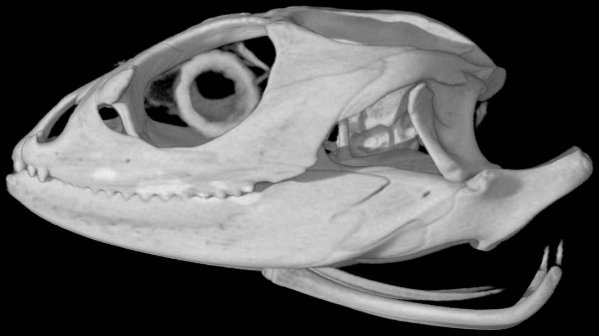
Scientific classification
Domain: Eukaryota
Kingdom: Animalia
Phylum: Chordata
Class: Reptilia
Order: Squamata
Family: Agamidae
Genus: Pogona

Special notes:
The bearded dragon or beardy, as some call them,
grow to a length of 17-19 inches from the tip
of the nose to the end of the tail. It is rather
difficult to tell a male from a female although
experienced herpetologists can do it rather accurately. These lizards are omnivores both in captivity and in the wild. They need exposure to UVB light in order to produce D3 in their skin which enables them to process calcium. Without UVB exposure, they will get bone and or growth deformities. They will eat a variety of vegetation and insects.
Unlike some lizards, bearded dragons do not grow back lost tails or limbs. So, if a tail or foot is lost (sometimes siblings will nip at each other) it will heal over and never grow back.
Many people do not know that they have a specialized scale on the top of their heads, between the eyes but farther back which can be distinguished by a black dot in the center. This scale is called a parietal eye or third eye and it is photosensitive. A bearded dragon's biggest predator in the wild is birds and birds attack from above. They have developed this scale that senses differences in light and shadow. If a shadow falls across the parietal eye, the dragon will take a defensive stance. For this reason, it is best to approach the beardy from the front and lift from the chest, so you do not freak it out by it sensing a shadow before it realizes that it is you.
Bearded dragons shed their skin. As babies, they will usually shed quite often and most of the body all at once. As adults, they will generally shed the skin on each part of the body once a year but in various pieces at a time.

When you are making your observations keep the following ideas in mind:

How has the adaptation/modification (whether it is the shape or size of the organism’s feet, wings, head or otherwise) helped it to reproduce and/or survive in its environment?

(Ex. The modification that might result from the flippers on the rear legs of the frog used for swimming, or the wings of a bat that help it to fly.)

Now, go to either Mr. Rierson or Mr. Cistaro and examine the bearded dragon and the cokatoo. Record yoru observations.

FEATURES OF THE COCKATOO FEATURES OF THE BEARDED DRAGON

COCKATOO BOTH BEARDED DRAGON
1. What features did you find to be the same in both organisms?

2. If you have not drawn/sketched both animals, go back and do so. Pay close attention to the head (eyes, face, ears, etc) and limbs. What similarities do you notice about these structures?

3. Look carefully at the toes on the bearded dragon and on the cokatoo. Similarities?

4. The basic idea behind cladistics is that members of a group share a common evolutionary history, and are "closely related," more so to members of the same group than to other organisms. BUT BEWARE, it is not enough for organisms to share characteristics, in fact two organisms may share a great many characteristics and not be considered members of the same group. For example, consider a jellyfish, starfish, and a human; which two are most closely related? (You will need the internet.)
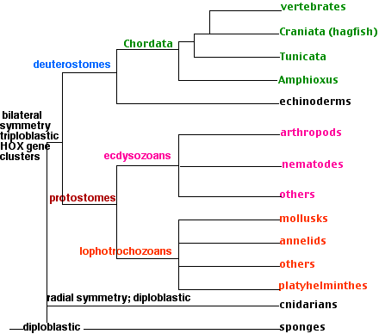
5. Like all other reptiles, birds have scales, is this homology or analogy? What is your evidence?

6. Assume the feathers are produced by tissues similar to those that produce scales, are birds’ feathers and reptiles’ scales homologous or analogous? What is your evidence?

Ask me to show you the last slide on the powerpoint.Instructor Initials_______

