Genome Sequencing For Babies Brings Knowledge And Conflicts
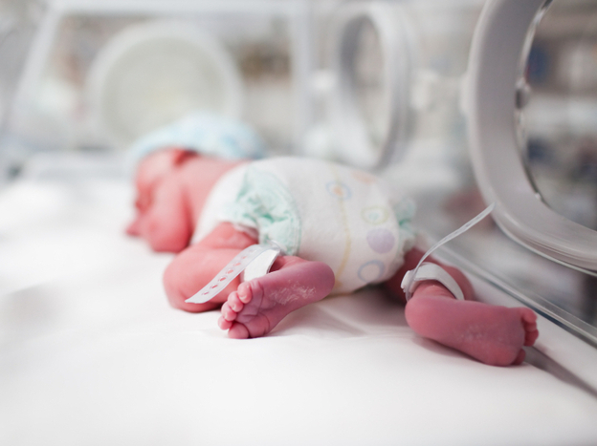
by ROB STEIN
December 03, 2012

By sequencing a newborn's genome, doctors could screen for more genetic conditions. But parents could be confronted with confusing or ambiguous data about their baby's health. iStockphoto.com

When Christine Rowan gave birth prematurely in August, her new baby was having problems breathing. So Rowan brought her daughter, Zoe, to the Children's National Medical Center in Washington, D.C., for genetic testing.

"It's funny because when we first had the testing done, we didn't even really think about the fact the testing was going to lay out all of her DNA," says Rowan, 32, who lives in Northern Virginia.
But while Rowan and her husband were waiting for the results, questions started popping into their heads.

"If we have all this information, when do we tell Zoe? You know, do we wait until she's a specific age and say, 'Oh, by the way we have all your DNA. ... Do you want to see what doctors have found?' " Rowan says.

"Or do we kind of keep that to ourselves? Or would it be better to just only get the information we really need and then genuinely not know so that we don't have to walk down that road? We don't really have that answer, at this moment."

Rowan's questions are at the heart of an intense debate over the prospect of using a test known as whole genome sequencing on babies.

Genome sequencing deciphers an individual's entire genetic code. The price of doing this has been dropping quickly, raising the possibility that sequencing can become more common than ever before. That includes the possibility of sequencing all babies when they're born.
Sequencing an individual's genome at birth would enable doctors to screen for far more genetic conditions than they do now. The hope is that it would catch more rare genetic conditions early, and help doctors prevent more complications and many deaths.

"Instead of screening for currently something like 30 conditions, it would allow you to screen for hundreds, if not thousands, [of conditions] at birth," says Dr. Alan Guttmacher, director of the National Institute of Child Health and Human Development.

But that's just the beginning. Sequencing lays out a person's entire genetic blueprint. So sequencing a newborn could spot babies prone to conditions such as obesity, diabetes, heart attacks or cancer and provide all kinds of clues about how to help them live longer, healthier lives.

"One could imagine a day where knowing someone's entire genome sequence at birth, you could really begin to think about structuring their health care, their dietary choices, their exercise choices ... early in life, in a way that would have an impact on truly lifelong health," Guttmacher says.
But this idea is also raising a lot of concerns.

"In theory it sounds absolutely fantastic," says sociologist Stefan Timmermans, who studies newborn screening at UCLA. "The reality is that there's a lot of uncertainty about each of the data points you receive. So if people start making health decisions or life-or-death decisions based on information that is so tenuous at this point, I think this could indeed be a nightmare scenario."

A nightmare, because parents could easily become overwhelmed with confusing or ambiguous information about the health of their baby during one of the most sensitive times in their lives.
There's plenty of evidence that parents already often overreact to the relatively small amount of data that they're getting from little spots of blood collected at birth. Bioethicist Mark Rothstein of the University of Louisville says the tests can lead to so-called vulnerable child syndrome.

These children "are viewed as medically vulnerable and medically frail," Rothstein says. "And so while all the other kids are riding bikes and climbing trees, these kids are sort of sitting in a corner. So they can't even enjoy a normal childhood."

And what if the sequencing reveals that a child has genes that may make them prone to diseases that may not show up for decades — and that they can't do anything about anyway?

"A lot of people just don't want to know that sort of thing, such as their risk for incurable diseases like Alzheimer's and Huntington's," says Benjamin Berkman, a bioethicist at the National Institutes of Health.

"Adults in large numbers choose not to know their status for those disorders," Berkman says. "And so you could imagine a parent wanting to know whether or not their child is going to get Alzheimer's and then telling the child at some point. But then when the child is an adult, [this knowledge has] changed their life in a way that they wished they could have lived without [it]."

Despite all this, there's talk about sequencing even earlier in life, when a fetus is still in the womb. Scientists in California and Washington reported this summer that they had done this for the first time.
Sequencing could help pregnant couples make important decisions, says the University of Washington's Dr. Jay Shendure, one of the researchers.
"Parents could elect for termination of the pregnancy in connection with the diagnosis of a particular disease," says Shendure. "In other circumstances, there may be opportunities [for] treatment of the fetus during pregnancy, as well as for treatment after birth."

But this raises all the same worries as sequencing newborns — overwhelming parents with fuzzy but terrifying results, casting a dark shadow over the future of their child. And when you're talking about doing this to a fetus in the womb, Berkman says all that could have even graver consequences.
"Our worry is that parents are going to be faced with this deluge of genetic information about the potential health of their unborn child. Parents may let their anxiety and confusion affect their reproductive choices in ways that they would later regret," Berkman says.

There are also concerns that parents might try to use sequencing to pick and choose babies who would be, say, good athletes, or get good grades.

"Parents will take that information, that computer readout, maybe go home and say, 'I want this child' or 'I don't want this child,' " says Ronald Green, a bioethicist at Dartmouth University. "A parent may decide, 'I want a child of lighter skin tone,' 'I want a girl with blond hair and blue eyes, and this child doesn't have it,' and so on and so on."

Proponents of sequencing acknowledge there are legitimate worries. So some, like Guttmacher, say it's important to scrutinize the technology and air these concerns now.

"As with any new technology, we should try to use it to benefit people, but when it's not very clear what its exact impact's going to be, we should go slowly. We should study it," Guttmacher says.

For her part, Rowan and her husband decided it was OK for doctors to look through Zoe's DNA for a gene associated with her sleep issues. But that's it. The couple didn't want doctors poking around much more than that.

"I'm just not willing to go down that road and kind of open up what I would call a can of worms. I just don't want to create a sense of fear in myself or my daughter," Rowan says.

It turned out Zoe doesn't have the sleep apnea gene or any other obvious genetic syndromes that could be affecting her breathing. She's doing better, though, and was able to go home a few weeks ago.
"I'm a firm believer we only have the grace for today. We don't have grace to deal with what might be down the road 10 years from now," Rowan says. "I'll have the grace I'll need once I'm there. But right now I only have enough grace for today. Tomorrow has enough worries."

STANDARD D4.ETS2.B Influence of Science, Engineering, and Technology on society and the natural world.
STANDARD B4.2h I can recognize that genetic engineering techniques provide great potential and responsibilities.
Discussions about ethics (morals) are important in many aspects of health care but are especially critical when the health care includes genetic testing. There are several aspects of genetic testing that may lead to ethical dilemmas (problems).
- Are there any limits to genetic testing?

- Should the information be obtained if no treatment or intervention exists?

- What are potential (possible) adverse (negative/bad) personal or societal consequences?

- Assume the gene you are looking for causes severe birth defects. What are the undesired options after genetic testing? Or to put it another way, what decisions would you have to make after doing genetic testing that you wouldn’t have to worry about if you never had the testing done?

- How are these decisions different from what you would have to decide after having a regular medical test, like blood pressure?

